**Simmer - Art Asset Summary**

* Narrative is still under development, but the underlying objective is for the character to exist in a world where the community is sharing the experience of food with each other and get a little brighter as the player engages more with the community and develops their own personal growth.
* For our game we chose to go with a comforting pixel art aesthetic. Since cooking is something done so often at home we wanted to enhance the player experience by using warm color palettes to make the kitchen as inviting as possible to the player. In addition to the color palettes we wanted to make the kitchen feel more lived in by adding plants to the decor to balance out all the metal cooking appliances. Our current point of view will be similar to the one Zelda’s Minish Cap uses for npc noises. This point of view will allow the player to traverse the entire kitchen and still get detailed decor all around.
  + 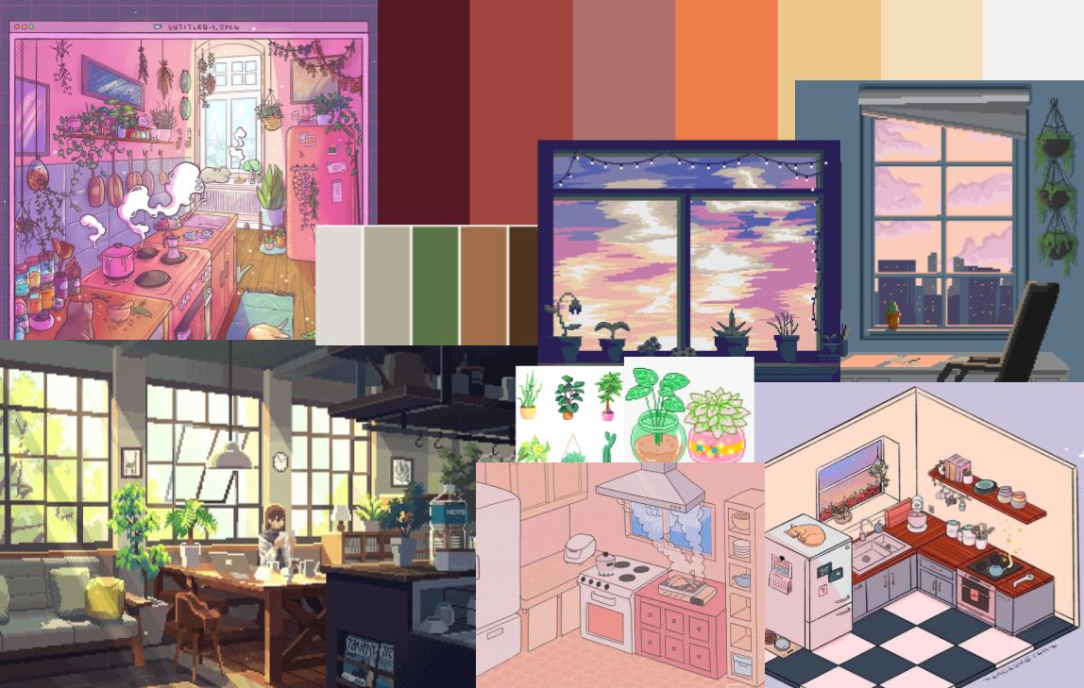
  + 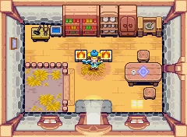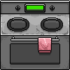
  + As for the asset art for food we wanted to go with simple and familiar shapes and colors to amplify the comforting and inviting feeling that cooking in the game gives off.
  + We decided to have simple ingredients to have minimal shading while the completed dish would have much for details in order to highlight the finished product that the player put so much effort into.
  + 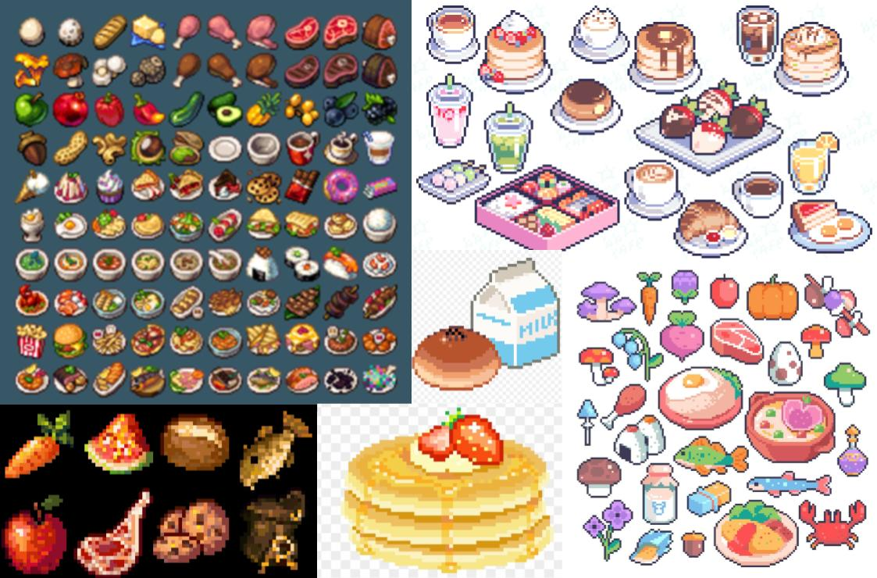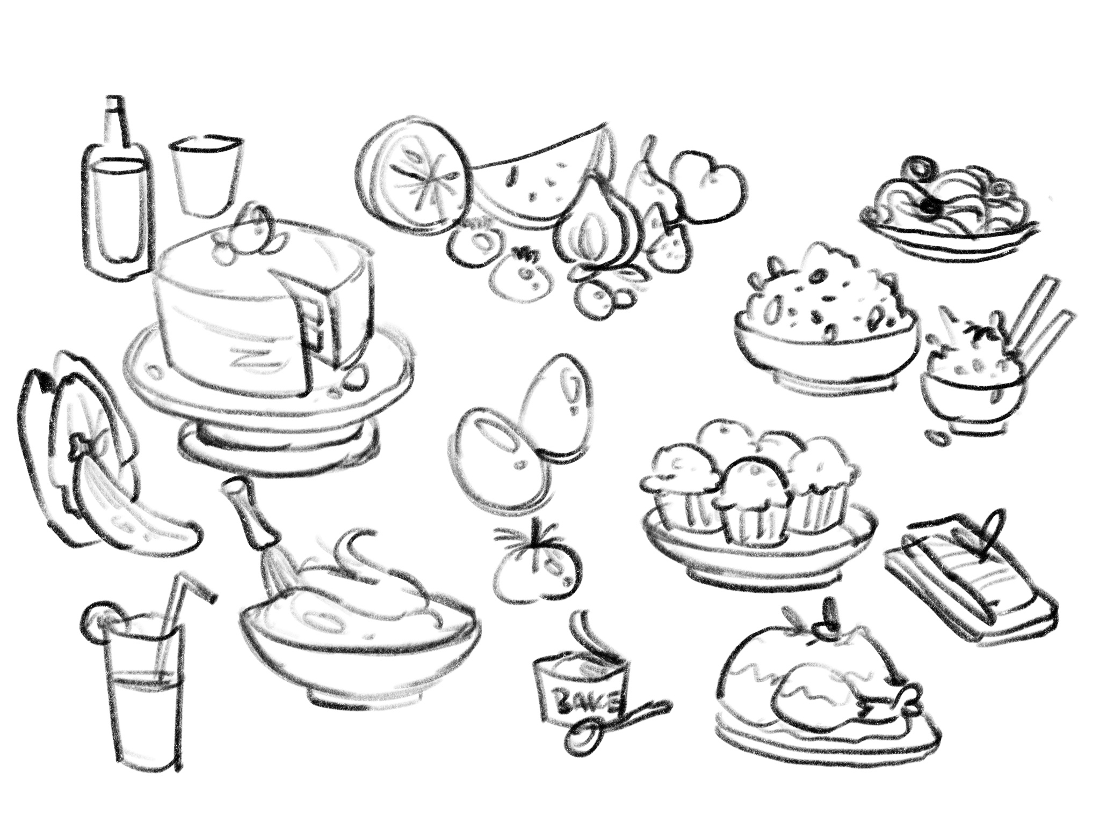
* Our sound design role is still not filled. This will either be delegated between Constantine and Ian or we will search for an external collaborator that can provide some kind of contribution. There will be a few key interactions for kitchenware and the environment outside of the kitchen, as well as a backing track, but we have not had the resources to allocate to this area of the game yet.